**NAME: MARIA KHUZEMA**

**ID NO: BIT-23F-031 – A**

**SUBJECT: ARTIFICIAL INTELLIGENCE**

**SEMESTER: 3RD**

**LAB 4:**

**LAB TASK 1:**Write a Python function to check if a number is even or odd.

**CODE:**

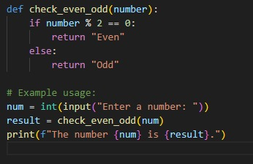

**OUTPUT**

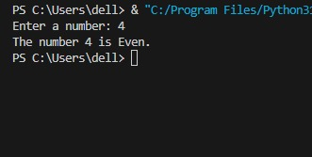

**LAB TASK 2:**

Write a Python function to find the maximum of three numbers.

**CODE:**

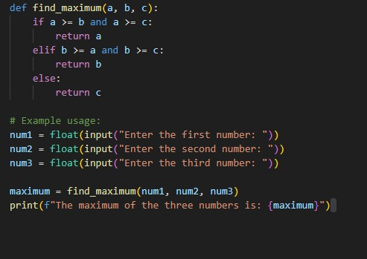

**OUTPUT:**

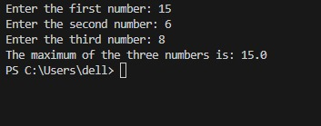

**LAB TASK 3:**

Make starred shapes using Loops.

**CODE:**

**RIGHT TRIANGLE:**

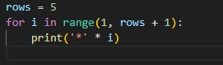

**OUTPUT:**

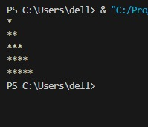

**CODE:**

**SIMPLE TRIANGLE:**

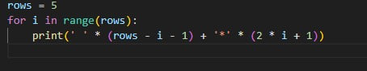

**OUTPUT:**

